Button Component

Properties Tab

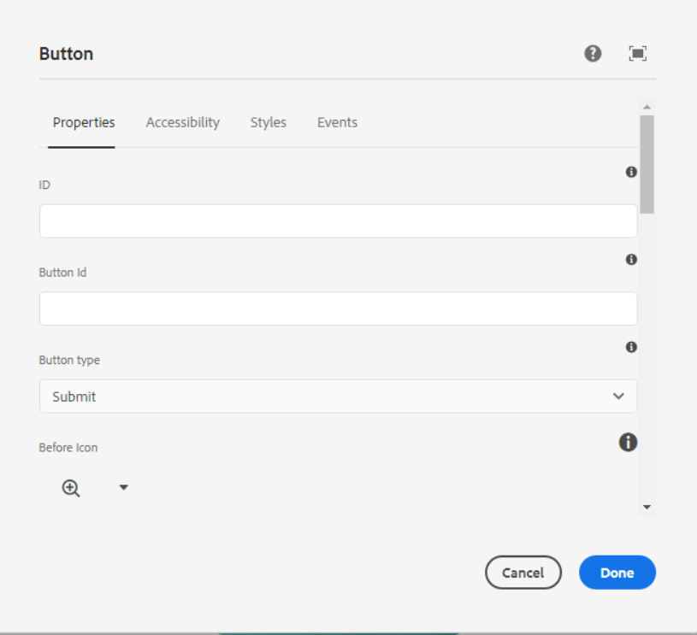

**ID – HTML ID attribute to apply the component.**

**Button ID – The Element id is for Button.**

**Button Type –** In this dropdown below list of types are available, we can select one type as per our requirement.

* None
* Submit
* Button
* Reset

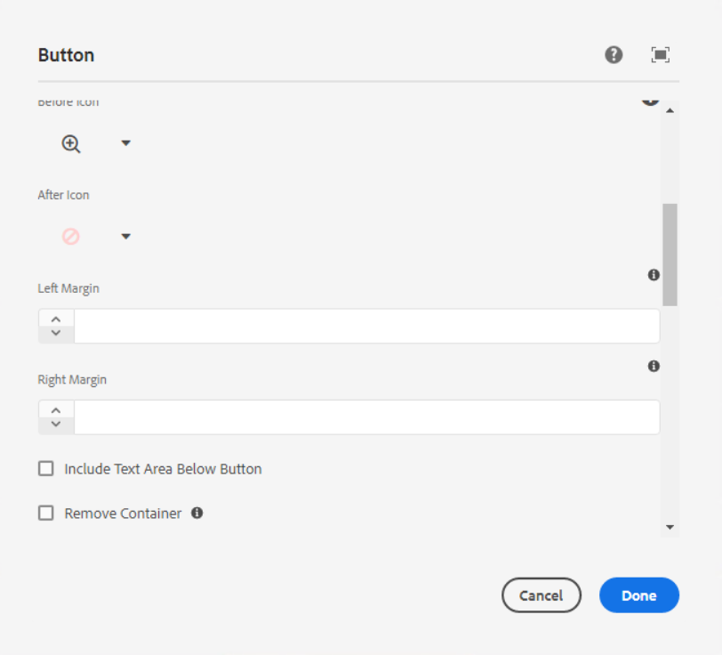

**Before Icon –** If we require icon before the text then we can select default icon from dropdown as per the requirement.

**After Icon –** If we require icon after the text then we can select default icon from dropdown as per the requirement.

**Left Margin –** Here we can set the left margin of the button in numeric format and if left margin is blank then 30px will be set on the mobile.

**Right Margin –** Here we can set the right margin of the button in numeric format and if right margin is blank then 30px will be set on the mobile.

**Checkbox for Include Text Area Below Button** – If we require text area below the button then we need to select the checkbox.

**Remove Container** - Check this to remove HTML container from the button (It will remove width and max-width of the button)

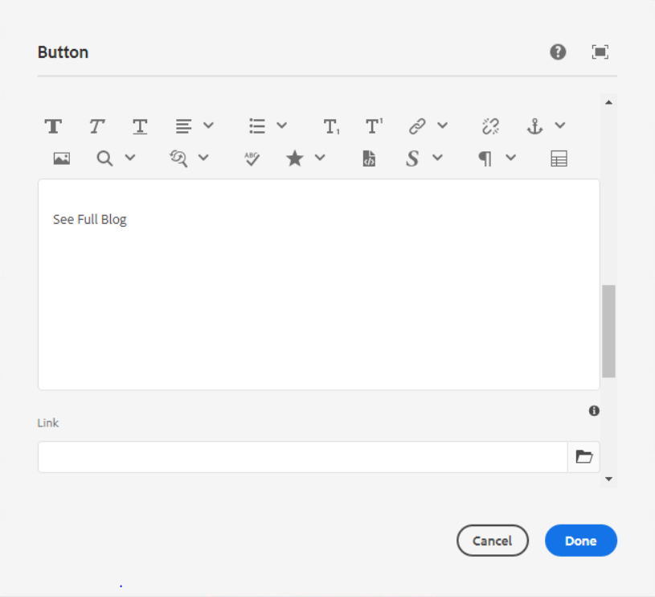

**Text –** The text to display on the button.

**Link** - Link to a content page, external URL or page anchor.

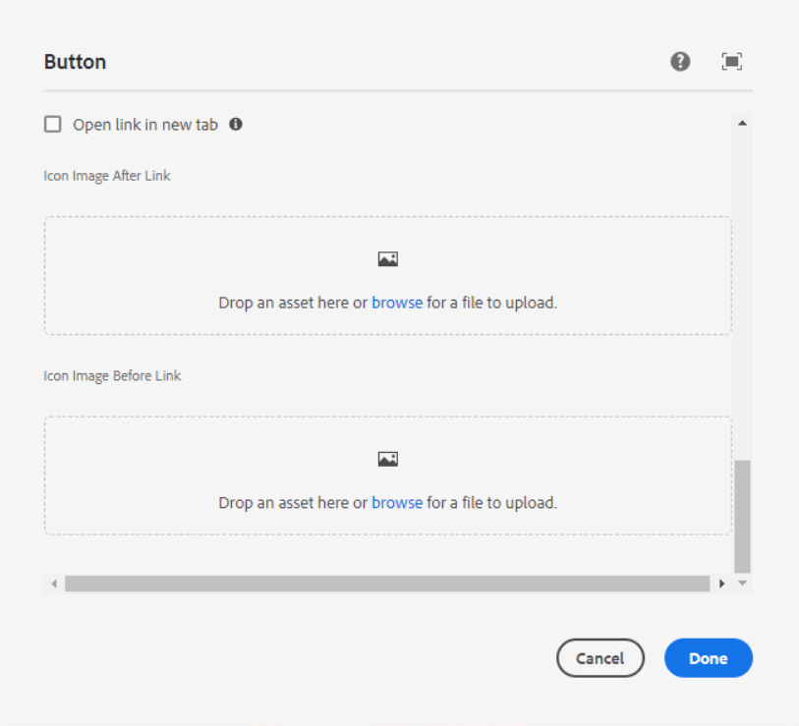

**Checkbox for Open link in new tab -** Check this if you want the button link to open in a new tab.

**Icon Image After Link** – Here we can add custom image icon to show after the button text

**Icon Image Before Link** – Here we can add custom image icon to before the button text

___________________________________________________________________

Accessibility Tab

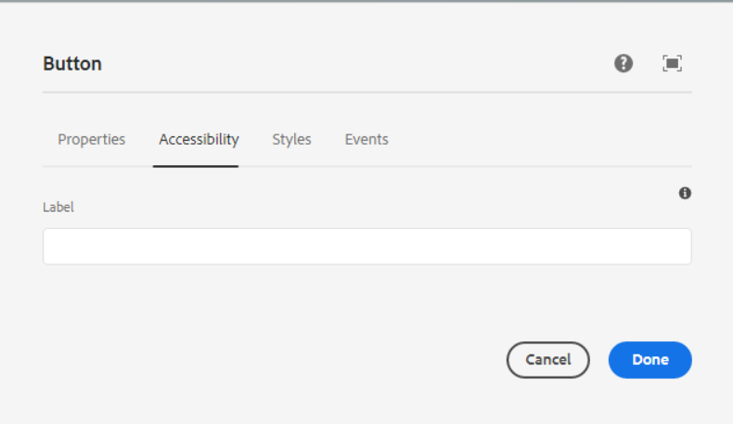

**Label** – Value of an aria-label attribute for the button. Useful if the visual button text is not very descriptive.

___________________________________________________________________

Styles Tab

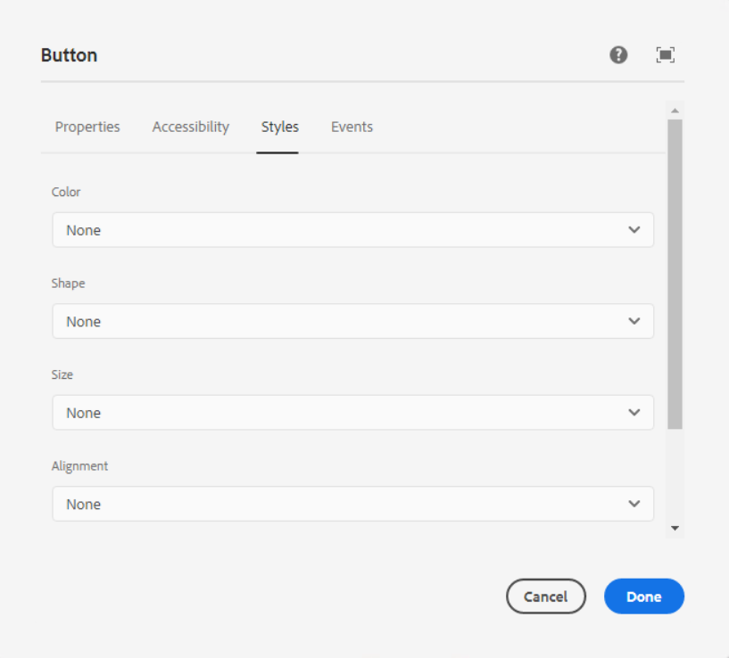

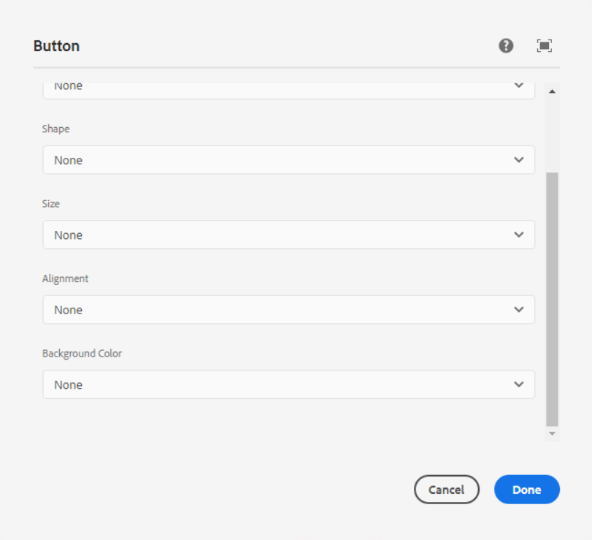

**Color -** In this dropdown below list of colors are available, we can select one color as per our requirement.

1. **Green Link**

Page Reference - <https://www.ancestry.com/corporate/>

AEM URL - <https://author-ancestry-dev2.adobecqms.net/content/ancestry-corp/us/en.html?wcmmode=disabled>



1. **Blue Link**

Page Reference - <https://www.ancestry.com/corporate/corporate-responsibility>

AEM URL - <https://author-ancestry-dev2.adobecqms.net/content/ancestry-corp/us/en/corporate-responsibility.html?wcmmode=disabled>



1. **Dark Blue**

Page Reference - <https://www.ancestry.com/corporate/corporate-responsibility>

AEM URL - <https://author-ancestry-dev2.adobecqms.net/content/ancestry-corp/us/en/corporate-responsibility.html?wcmmode=disabled>



1. **Green**

Page Reference - <https://www.ancestry.com/corporate/corporate-responsibility>

AEM URL - <https://author-ancestry-dev2.adobecqms.net/content/ancestry-corp/us/en/corporate-responsibility.html?wcmmode=disabled>



1. **Green Accent**
2. **Green Gradient**

Page Reference - <https://www.ancestry.com/corporate/>

AEM URL - <https://author-ancestry-dev2.adobecqms.net/content/ancestry-corp/us/en.html?wcmmode=disabled>



1. **Light Blue Gradient**

Page Reference - <https://www.ancestry.com/corporate/au>

AEM URL - <https://author-ancestry-dev2.adobecqms.net/content/ancestry-corp/us/en/global-newsrooms/au/newsroom.html?wcmmode=disabled>



1. **Blue Gradient**

Page Reference - <https://www.ancestry.com/corporate/>

AEM URL - <https://author-ancestry-dev2.adobecqms.net/content/ancestry-corp/us/en.html?wcmmode=disabled>

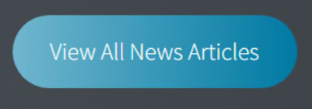

1. **Dark Blue Gradient**

Page Reference - <https://www.ancestry.com/corporate/>

AEM URL - <https://author-ancestry-dev2.adobecqms.net/content/ancestry-corp/us/en.html?wcmmode=disabled>



1. **Arrow link Forword**

Page Reference - <https://www.ancestry.com/corporate/blog/give-more-meaning-spring-cleaning-new-tools-preserve-family-photos-forever>

AEM URL - <https://author-ancestry-dev2.adobecqms.net/content/ancestry-corp/us/en/blog/give-more-meaning-spring-cleaning-new-tools-preserve-family-photos-forever.html?wcmmode=disabled>



1. **Arrow Link Back**

Page Reference - <https://www.ancestry.com/corporate/newsroom/press-releases/ancestry-integrates-photomynes-best-class-technology-help-mobile-customers>

AEM URL - <https://author-ancestry-dev2.adobecqms.net/content/ancestry-corp/us/en/newsroom/press-releases/ancestry-integrates-photomynes-best-class-technology-help-mobile-customers.html?wcmmode=disabled>



1. **Arrow Link White**

Page Reference - <https://www.ancestry.com/corporate/>

AEM URL - <https://author-ancestry-dev2.adobecqms.net/content/ancestry-corp/us/en.html?wcmmode=disabled>



1. **Arrow link Black text**

Page Reference - <https://www.ancestry.com/corporate/about-ancestry/our-brands>

AEM URL - <https://author-ancestry-dev2.adobecqms.net/content/ancestry-corp/us/en/about-ancestry/our-brands.html?wcmmode=disabled>



**Shape -** In this dropdown below list of shapes are available, we can select one shape as per our requirement.

* **None**
* **Square**
* **Round**

------------------------------------------------------------------------------------------------------------ **Size -** In this dropdown below list of size's are available, we can select one size as per our requirement.

1. **None**
2. **Extra small**
3. **Small**

Page Reference - <https://www.ancestry.com/corporate/corporate-responsibility>

AEM URL - <https://author-ancestry-dev2.adobecqms.net/content/ancestry-corp/us/en/corporate-responsibility.html?wcmmode=disabled>



1. **Default (Medium)**
2. **Large**

Page Reference - <https://www.ancestry.com/corporate/>

AEM URL - <https://author-ancestry-dev2.adobecqms.net/content/ancestry-corp/us/en.html?wcmmode=disabled>



------------------------------------------------------------------------------------------------------------ **Alignment -** In this dropdown below list of alignment’s are available, we can select one alignment as per our requirement.

* **None**
* **Left**
* **Center**
* **Right**

------------------------------------------------------------------------------------------------------------ **Background Color -** In this dropdown below list of background colors are available, we can select one color as per our requirement.

* **None**
* **White (Default)**
* **Green**
* **Blue**